**Project: Car Game with Framework**

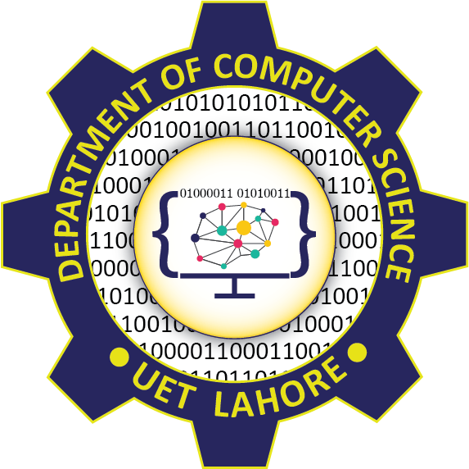

Session: 2021 – 2024

**Submitted by:**

Your Name Haider Sultan Your Registration No 2021-CS-85

**Supervised by:**

Dr.Awais

Department of Computer Science

**University of Engineering and Technology**

**Lahore Pakistan**

**Important Instructions**

**Here you can find the major parts of your Game documentation**

* Table of Contents
* Short Description of your Game
* Game Characters Description
* Rules & Interactions
* Goal of the Game
* Features of Framework
  + You have to write how many features your framework provide.
  + i.e., Following are the features of this framework.
  + 1. Movement Framework
  + 2. Collision Framework
  + 3. Firing Framework
  + Ability of extent all these according to the new user’s requirement
* Class diagram
  + Do not auto generate from the VS. You have to draw on some external software. E.g., draw.io
  + Diagram should be clear and easily readable.
  + Unclear diagrams without showing the access modifiers, association and multiplicity are not acceptable.
* Sequence diagram
  + Do not auto generate from the VS. You have to draw on some external software. E.g., draw.io
  + Diagram should be clear and easily readable.
* Example usage of your framework.
  + You have to write all the details how someone can use your framework. Which objects he/she has to create, what are the function names that he/she has to make, and how to use your framework (sample examples should be given) and how to extend your framework. Explain with the help of examples in detail so that anyone can easily use your framework after reading these sample examples.
* Complete Code

**Formatting Instructions**

1. Heading Size is 16
2. Sub heading size is 14
3. Further heading size is 13
4. Make your heading font bold
5. Text Font size is 12
6. Use Times New Roman Font Style
7. Text paragraphs should be justified. (Justify is feature of MS World)
8. Code Size should be 10 and 1.0 line Spacing to make it compact
9. Follow proper coding Styles to make the classes and driver program